
CENTER FOR SKILL AND ENTREPRENEURSHIP DEVELOPMENT (CSED)
PROJECT REPORT
Job Market Skills and Salary Analysis
BTECH INTRO TO DATA ANALYTICS
PROGRAM CODE: DA-021
PROGRAM NAME : Career & Labour Market Analytics
MENTOR NAME : UNWAN SIR

DEPARTMENT OF COMPUTER SCIENCE AND ENGINEERING
COURSE: B.TECH (CSE) SECTION: [SECTION]

TEAM MEMBERS AND STUDENT IDENTIFIERS
TEAM MEMBER | STUDENT ID
LOKESH SHUKLA | BCS2025401
SUDHANSHU SINGH | BCS2025402
RISHABH GUPTA | BCS2025406
ANURAG VERMA | BCS2025409
HARSHITA UPADHYAY | BCS2025411
ZAINUL ALI | BCS2025413
AYUSHI | BCS2025414
NILANSH GUPTA | BCS2025416
PRANAY KESARWANI | BCS2025417
MOHAMMAD MUNEER | BCS2025418
KAVYANSH BHADRI | BCS2025419
ABHAY | BCS2025421
SARVESH SINGH | BCS2025422
SACHIN | BCS2025424

Submitted in partial fulfilment of the academic project requirements.
Academic Year: 2026-27

INDEX

S. NO. | SECTION | PAGE
1 | 1. Introduction
2 | 2. Problem Statement
3 | 3. Objectives Of The Project
4 | 4. Methodology
5 | 5. Literature Review
6 | 6. Explanation Of Project (Working)
7 | 7. Workflow
8 | 8. Program
9 | 9. Result & Discussions
10 | 10. Snippets Of Ui
11 | 11. Future Scope
12 | 12. Conclusion
13 | References and Bibliography

SYSTEM ARCHITECTURE DIAGRAM
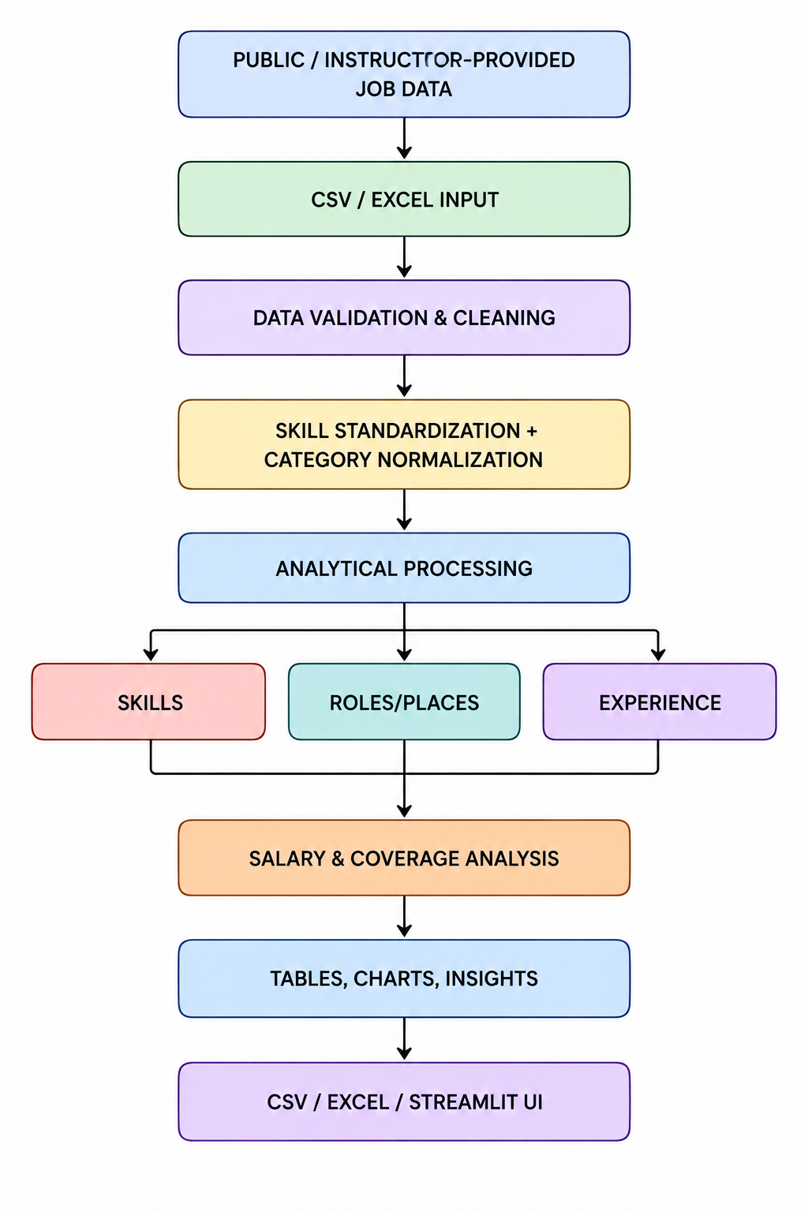

1. INTRODUCTION
The labour market changes continuously as organizations adopt new technologies, revise business processes and respond to economic conditions. Job advertisements provide a useful, though incomplete, view of the skills employers say they need. When many advertisements are examined together, they can reveal recurring technical skills, common job roles, location patterns, experience requirements and the extent to which employers disclose salary information.
The project, Job Market Skills and Salary Analysis, applies Python-based data analytics to a legally accessible dataset of job advertisements. It uses Pandas for data preparation and analysis, NumPy for numerical operations, and Matplotlib/Seaborn for visual presentation. The analysis is intended to support students, educators and early-career job seekers in understanding the requirements visible in the selected job-posting sample.
The project examines five connected dimensions: -
- skill frequency
- job-role distribution
- geographical distribution
- experience requirements
- salary information and its missingness. Skills are standardized before counting so that common spelling variants such as “JS” and “JavaScript” can be treated consistently where the context makes the mapping valid.
The output is a set of cleaned data files, frequency tables, charts and evidence-based observations. The results describe the dataset and observation period used; they must not be interpreted as a complete census of all jobs or all hiring activity in India.
2. PROBLEM STATEMENT
Students and fresh graduates often find it difficult to decide which technologies and competencies to prioritize. Job information is spread across multiple websites and datasets, and job advertisements are not always presented in a consistent structure. The same skill may be written in different ways, job titles may vary between employers, experience requirements may be expressed as ranges or free text, and salary information may be absent or reported using different units.
Manual review of a large number of advertisements is slow and makes comparisons difficult. A structured analytical process is therefore required to clean job-posting records, standardize skill names, count skill mentions, compare roles and locations, summarize experience requirements and report salary coverage.
The project addresses the following problem: how can a reproducible Python data-analysis workflow transform a selected collection of legally accessible job advertisements into clear, interpretable evidence about advertised skills, roles, locations, experience requirements and disclosed salaries?
The analysis is descriptive rather than predictive. Unless a separate predictive model is developed and validated, the project does not claim to forecast salaries, hiring outcomes or an individual's probability of getting a job.

3. OBJECTIVES OF THE PROJECT
- Load job-posting data from CSV or Excel files and inspect its structure and provenance.
- Remove duplicate records using a stable job identifier or a documented fallback key.
- Clean text fields and standardize skill names using a transparent mapping dictionary.
- Calculate the frequency and percentage of job advertisements mentioning each skill.
- Compare the distribution of advertised job roles and locations.
- Summarize experience requirements using the categories present in the source data.
- Analyze salary values only after checking currency, pay period and salary units.
- Measure salary coverage and missing-salary percentage explicitly.
- Create clear charts and export cleaned data, analytical tables and figures.
- Translate the findings into cautious learning-priority observations for students and educators.
Measurable project outputs include a cleaned dataset, a skill-frequency table, role and location summaries, an experience summary, salary statistics where valid salary data exists, a salary-coverage calculation, visualizations and a documented final interpretation.

4. METHODOLOGY

4.1 Research design
The project uses a quantitative, descriptive, cross-sectional analysis of job advertisements captured in a defined dataset and observation period. The unit of analysis is one unique job advertisement or requisition after deduplication. A posting may mention several skills, so skill counts are multi-label counts: one posting can contribute to more than one skill.

4.2 Data source and collection
The primary input should be an instructor-provided dataset or a public dataset whose licence and terms permit the intended academic use. Record the dataset title, publisher, download URL, licence, download date, geographic coverage, observation period, row count and any known collection method. Do not scrape websites unless the site's terms, permissions and applicable law allow it. Public visibility alone is not permission to scrape.
A possible supplementary source is the Jobspiq public repository, which publishes dated aggregate snapshots of Indian technology skill demand and employer-stated salary statistics under CC BY 4.0. Its published files are aggregate data, not individual job advertisements; therefore, they are suitable for contextual comparison but cannot independently support every row-level role, company, location or experience analysis described here. The primary analysis in this report assumes an individual-posting CSV/Excel dataset.

4.3 Suggested dataset fields
Field | Description | Use in analysis
Job_ID | Unique advertisement identifier | Deduplication
Job_Title | Advertised role title | Role comparison
Company | Employer name, if available | Optional employer analysis
Location | City/region or remote location | Geographical comparison
Skills | Skill list or job-description text | Skill extraction and counting
Experience | Experience requirement | Experience distribution
Min_Salary | Lower salary bound | Salary analysis
Max_Salary | Upper salary bound | Salary analysis
Currency / Pay_Period | Currency and monthly/annual/hourly basis | Salary normalization
Posted_Date | Date the advertisement was posted | Time-period filtering

4.4 Data preprocessing
- Inspect dimensions, column names, data types and missing-value counts.
- Trim whitespace and normalize case in text fields.
- Remove exact duplicates and, where appropriate, duplicate requisitions from multiple sources.
- Convert salary fields to numeric values only after removing formatting characters and validating units.
- Preserve missing salary values as missing; do not replace them with zero.
- Normalize locations and experience categories only when a defensible mapping is available.
- Retain a copy of the raw input and write cleaned outputs separately for reproducibility.

4.5 Skill standardization and extraction
If the dataset already contains a structured Skills column, split the field using the source delimiter and normalize each item against a documented alias dictionary. If only job-description text is available, use a controlled skill vocabulary and carefully designed phrase matching; inspect ambiguous abbreviations manually. For example, “ML” may mean Machine Learning in a technical context, but abbreviations should not be mapped blindly. The report should document the vocabulary and any manual review.
Skill frequency is reported as the number of unique advertisements mentioning a skill. Skill share is calculated as the number of unique advertisements mentioning that skill divided by the total number of eligible unique advertisements, multiplied by 100. Because advertisements can mention multiple skills, skill shares do not need to sum to 100 percent.

4.6 Exploratory data analysis
- Use value_counts() to summarize job titles and locations.
- Use explode() and value_counts() to count normalized skills across advertisements.
- Use groupby() to compare skills by job role or location.
- Summarize experience categories after normalizing equivalent labels.
- Calculate salary median, quartiles and range for comparable salary records.
- Measure salary coverage as records with usable salary data divided by all eligible records.

4.7 Salary treatment
Salary comparisons are valid only when currency and pay period are comparable. The project should convert values to a common basis (for example, annual INR) only when the source provides enough information to do so reliably. If a posting gives a salary range, the lower and upper bounds should be retained. A midpoint may be calculated for a simple descriptive comparison, but it must be labelled as an estimate derived from the stated range, not as the actual offered salary. Median and quartiles are generally more robust than the mean when salary distributions are skewed.

4.8 Ethical, legal and quality considerations
- Use only data that is legally accessible and licensed or otherwise authorized for the intended use.
- Do not collect personal contact details or unnecessary personal information.
- Document the collection date, source, licence, coverage and known limitations.
- Do not treat job-posting counts as actual hires, vacancies filled or total labour demand.
- Do not generalize a small or biased sample to the entire labour market.

5. LITERATURE REVIEW
Khaouja, Kassou and Ghogho (2021) reviewed research on skill identification from online job advertisements. Their survey describes how job advertisements contain unstructured text that requires processing before skills can be identified. The review covers skill bases, extraction methods, sectors and applications. This supports the project's use of text cleaning, skill normalization and structured skill-frequency analysis.
Fabo and Kureková (2022), in an International Labour Organization working paper, examine the opportunities and methodological weaknesses of online labour-market data. They discuss non-representativeness, changes in data volume and structure, and approaches for interpreting online vacancy and applicant data. Their work supports the project's decision to describe the selected sample and avoid treating online postings as a complete picture of the labour market.
The OECD discussion of online job postings as a data source explains that online vacancies offer granular information about skills but may not represent all vacancies. It also notes that some skills may be omitted from advertisements because employers assume them or do not consider them necessary to list. This is relevant when interpreting skill counts: a skill not mentioned in a posting is not necessarily irrelevant to the job.
Napierała (2024) discusses taxonomy-based extraction of digital skills from job advertisements and the role of natural-language processing in improving skill identification. This supports the future extension of the project from simple dictionary matching to more advanced taxonomy- or NLP-based extraction.
The Jobspiq public data repository provides dated aggregate snapshots of Indian technology skill demand and employer-stated salaries under CC BY 4.0. Its documentation explains its snapshot windows and limitations, including the fact that the data are aggregate rather than individual job records and that stated salaries are not a random sample of all employers. It can therefore serve as a supplementary benchmark, not a replacement for an individual-posting dataset.
Research synthesis: prior work establishes that online job advertisements are valuable for examining advertised skill requirements, but the data require careful cleaning, normalization and interpretation. This project applies those principles in a transparent, reproducible Python workflow.

6. EXPLANATION OF PROJECT (WORKING)

6.1 Input stage
The system accepts a CSV or Excel file containing job advertisements. The user specifies or confirms the input file and the expected column names. The program checks whether the required fields are present and reports missing columns before analysis begins.

6.2 Cleaning stage
The program standardizes column names, trims whitespace, converts blank strings to missing values, removes duplicate records and converts salary fields to numeric values. The raw file remains unchanged so the cleaning process can be repeated and audited.

6.3 Skill processing stage
The Skills field is split into individual skill labels. Each label is cleaned and mapped to a canonical name using an alias dictionary. Duplicate mentions of the same skill within one advertisement are counted once for that advertisement. The program then calculates skill counts and the percentage of unique advertisements mentioning each skill.

6.4 Comparative analysis stage
The program counts job advertisements by title and location, summarizes experience labels and groups skills by role where the relevant columns exist. Filters can be applied to focus on selected job families, locations or date ranges.

6.5 Salary analysis stage
The program identifies records with usable salary values, computes a midpoint when both salary bounds are present, and summarizes comparable values. It reports both the number of salary observations and the proportion of the dataset for which salary data are available. Missing salaries remain missing and are not interpreted as zero pay.

6.6 Output stage
The system exports cleaned data, skill-frequency results, role counts, location counts, salary summaries and charts. An optional Streamlit dashboard can display the results using KPI cards, filters, tables and visualizations.

7. WORKFLOW
The project follows the workflow below. Each stage produces an output that is used by the next stage.
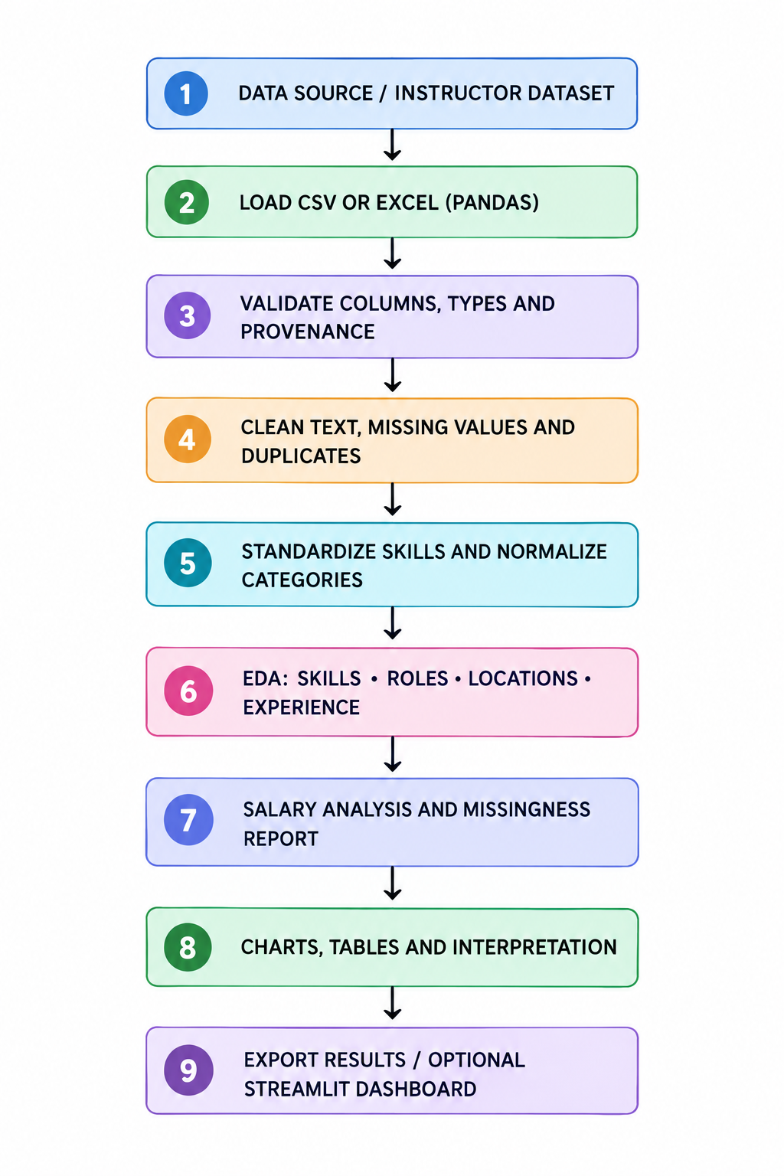
The workflow is reproducible when the source file, collection date, cleaning rules, skill dictionary, code version and output files are retained together.

8. PROGRAM
The following program is a reference implementation for an individual job-posting dataset. It expects a CSV file named job_postings.csv with at least Job_Title, Location and Skills columns. Job_ID, Experience, Min_Salary and Max_Salary are recommended. Rename the fields in the configuration section if the source dataset uses different names.

Program notes: (1) The sample code assumes a structured, delimited Skills field. If the dataset contains full descriptions instead, a reviewed skill vocabulary or NLP extraction stage is required. (2) The code does not automatically convert currencies or monthly salaries to annual salaries. Verify and normalize these before comparing values. (3) The fallback duplicate key is only a practical approximation; a stable requisition identifier is preferable. (4) Skill frequency is based on unique postings, not the number of repeated mentions inside one description.

9. RESULT & DISCUSSIONS
The final numerical results must be generated by executing the program on the selected and documented dataset. No dataset was supplied with the report request; therefore, this report does not claim actual counts, salary averages, top cities or top skills. The following result tables define exactly what should be populated after execution.
Result | Value to report | Interpretation
Dataset size | [N] unique postings | Size of analyzed sample
Observation period | [Start–end date] | Time coverage
Top skill | [Skill and count] | Most frequent normalized skill
Top job role | [Role and count] | Most common advertised role
Top location | [Location and count] | Most represented location
Most common experience group | [Group and count] | Experience pattern in sample
Salary coverage | [X%] ([n] of [N]) | Share with usable salary data
Median salary | [Value and unit] | Median among salary-reporting records only

9.1 Skill-frequency discussion
The skill-frequency table should be interpreted as the number and share of unique advertisements that mention each standardized skill. A high count indicates that the skill is frequently requested in the selected sample. It does not prove that the skill is sufficient for employment or that every employer requires it.

9.2 Role and location discussion
Role and location charts show how the selected records are distributed. A location with more records may reflect the dataset's source coverage, collection method or industry mix, not necessarily a greater total number of jobs in that location. Similar caution applies to job-title comparisons.

9.3 Experience discussion
Experience labels should be normalized only where their meanings are equivalent. “Fresher”, “0–1 years” and “0–2 years” should not automatically be combined unless the project defines and justifies a common category. The report should state how many records had missing or unclear experience information.

9.4 Salary discussion
Salary statistics describe only advertisements with usable salary data. Salary disclosure is often selective; the salary-reporting subset may differ from postings that do not disclose pay. Report the salary sample size next to every comparison. Avoid presenting a mean or midpoint as a guaranteed salary for a role.

9.5 Learning-priority observations
Learning priorities should be derived from the observed skill frequencies and role-specific comparisons. A defensible recommendation may identify a foundational skill that appears across several target roles, followed by role-specific tools. The recommendation should also consider the student's target role, prerequisites and curriculum. Frequency alone is not a complete measure of skill importance.

9.6 Limitations
- Online advertisements do not represent every job opening, particularly jobs filled through referrals or offline channels.
- Duplicate detection may be imperfect when employers repost or syndicate the same requisition.
- Skills may be omitted, described vaguely or expressed using ambiguous abbreviations.
- Salary data may be missing, selective, incomparable or based on different pay periods.
- A short observation window may reflect temporary hiring patterns.
- The dataset may overrepresent certain sectors, employers, cities or seniority levels.

10. SNIPPETS OF UI
The first version can be delivered in Jupyter Notebook with tables and static charts. For a more accessible demonstration, an optional Streamlit dashboard can present the same outputs in a browser. The dashboard should identify the dataset source and snapshot date so that users understand the scope of the results.

10.1 Proposed dashboard layout
- Overview: total unique postings, number of roles, number of locations and salary coverage.
- Skills: searchable skill-frequency table and top-skills bar chart.
- Roles: job-title counts and skill comparisons for a selected role.
- Locations: location distribution and role mix by location.
- Experience: experience-category distribution and missing-value count.
- Salaries: salary distribution, median by role and salary sample sizes.
- Export: download cleaned records and summary tables.
Any screenshot inserted into the final submission should be captured from the actual running dashboard. Do not submit mock dashboard values as if they were computed results.

11. FUTURE SCOPE
- Authorized periodic data refresh: connect to permitted APIs, licensed feeds or updated public datasets and retain dated snapshots.
- Natural Language Processing: extract skills from complete job descriptions using phrase matching, taxonomies or validated NLP models.
- Skill taxonomy mapping: map skills to a controlled vocabulary such as ESCO or O*NET where suitable, while respecting the geography and definitions of each taxonomy.
- Role-specific skill-gap analysis: compare a student's declared skills with the skills observed in advertisements for a selected target role.
- Interactive filtering: allow users to filter by city, job family, experience level, date and work mode.
- Salary normalization: add explicit currency conversion and monthly/annual/hourly normalization with source and conversion-date records.
- Trend analysis: compare dated snapshots to identify changes in advertised skill frequency over time.
- Machine learning: explore salary-range prediction or job-category classification only after sufficient data quality, feature validation and out-of-sample evaluation.
- Explainable recommendations: show which observed postings and skill counts support each learning recommendation.
- Deployment: host the Streamlit dashboard with versioned datasets and documented update procedures.
Any future predictive feature should be treated as a separate model-development task. It would require a suitable target variable, train/test separation, leakage checks, evaluation metrics and clear communication of uncertainty.

12. CONCLUSION
Job Market Skills and Salary Analysis demonstrates how a structured Python data-analysis workflow can transform job-posting records into useful information about advertised skills, job roles, locations, experience requirements and salary disclosure. Pandas supports data cleaning, normalization, grouping and aggregation, while Matplotlib and Seaborn make the results easier to inspect and communicate.
The project places particular emphasis on transparent skill standardization, salary coverage and responsible interpretation. It distinguishes the frequency of skills in a selected sample from a complete measure of labour-market demand, and it treats salary statistics as conditional on the records that actually disclose usable pay information.
The resulting tables, charts and optional dashboard can help students and educators compare learning priorities with the requirements visible in a defined set of job advertisements. With better data coverage, repeated snapshots and validated NLP methods, the project can be extended into a broader career-intelligence tool.
Overall, the project provides a practical application of data analytics to career and labour-market research. Its value lies not only in producing charts, but in documenting where the data came from, how it was cleaned, what the results do and do not show, and how the findings can be used responsibly.

REFERENCES AND BIBLIOGRAPHY
- Khaouja, I., Kassou, I., & Ghogho, M. (2021). A Survey on Skill Identification From Online Job Ads. IEEE Access, 9, 118134–118153. https://doi.org/10.1109/ACCESS.2021.3106120
- Fabo, B., & Kureková, L. M. (2022). Methodological issues related to the use of online labour market data. International Labour Organization, Working Paper 68. https://doi.org/10.54394/ZZBC8484
- OECD. (2022). Online job postings as a data source to analyse the impact of digitalisation on labour markets. In Skills for the Digital Transition. https://www.oecd.org/en/publications/skills-for-the-digital-transition_38c36777-en/full-report/component-5.html
- Napierała, J. (2024). Enhancing taxonomy-based extraction: Leveraging information from online community platforms for digital skills demand identification in job ads. Statistical Journal of the IAOS, 40(3). https://doi.org/10.3233/SJI-230110
- Jobspiq. (2026). Jobspiq public data: India's tech job market (dated snapshots). CC BY 4.0. https://github.com/jobspiq/jobspiq-public
- Python Software Foundation. Python documentation. https://docs.python.org/3/
- The pandas development team. pandas documentation. https://pandas.pydata.org/docs/
- Matplotlib Development Team. Matplotlib documentation. https://matplotlib.org/stable/
- Streamlit, Inc. Streamlit documentation. https://docs.streamlit.io/

END OF REPORT

